Tests

## Test 1 – Microsoft logo appears when it’s their go



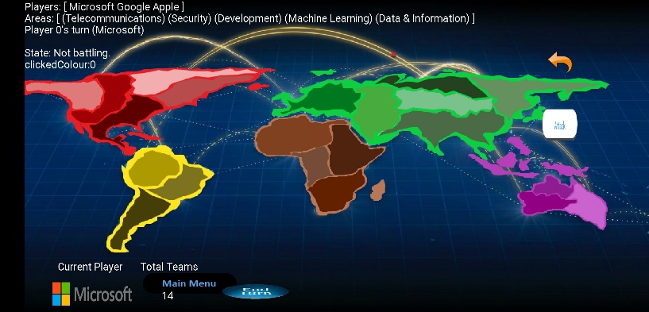

## Test 2 – Apple Logo appears when it’s their go



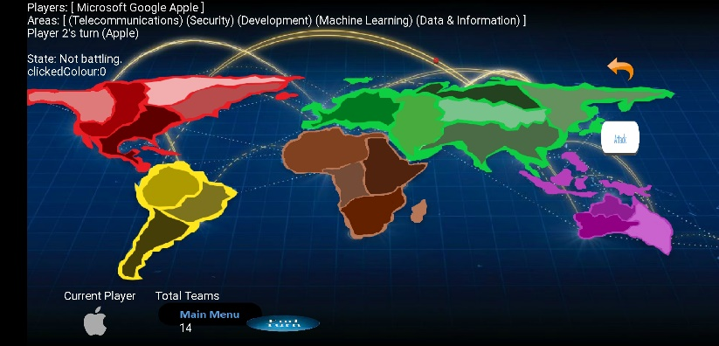

## Test 3 – Google Logo appears when it’s their go



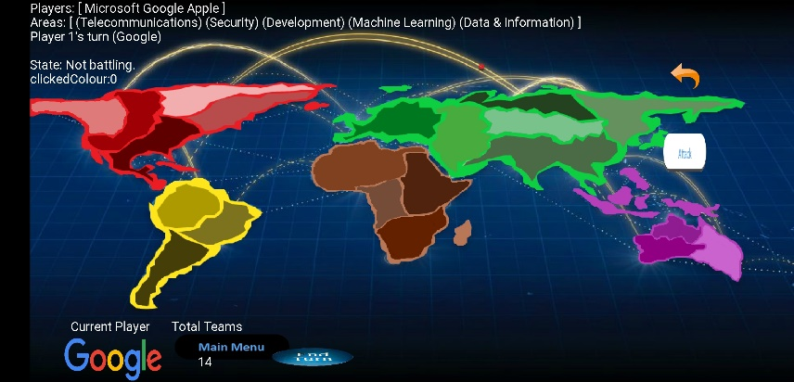

## Test 4 – Check if number of teams appear when it’s Microsoft’s go

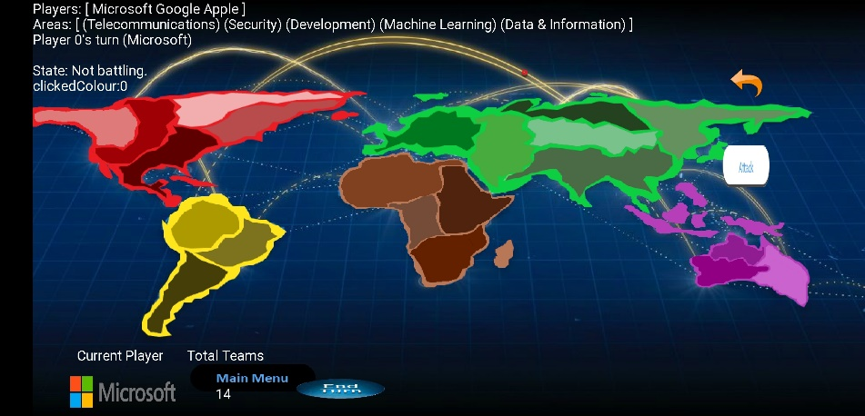

## Test 5 - Check if number of teams appear when it’s Apple’s go

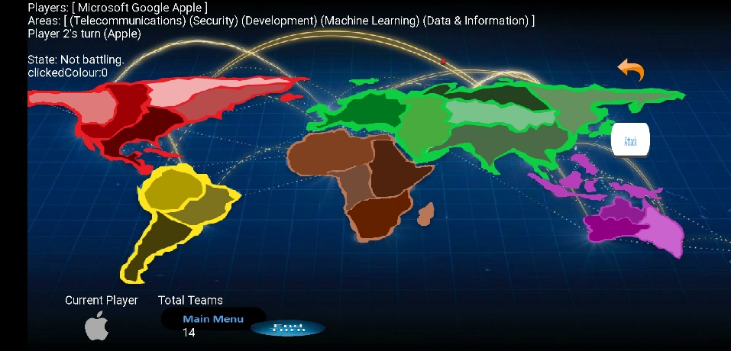

## Test 6 - Check if number of teams appear when it’s Google’s go

